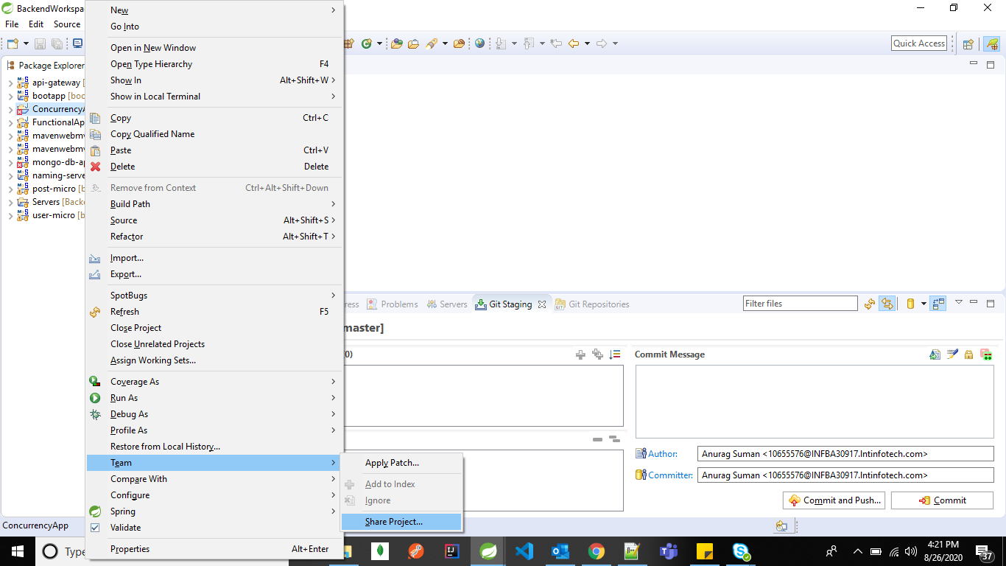

All the folder/files move from local to github

10655576@INFBA30917 MINGW64 /d/Full Stack Training/BackendWorkspace (master)

$ git init

$ git add .

$ git status

$ git commit -m "lti training all the project 26-08-2020"

$ git remote add origin https://anuragsuman@github.com/anuragsuman/LTI-Full-Stack-Training.git

$ git push -u origin master

Provide the username & password.

Anuragsuman26@gmail.com,R******S@8911

[https://github.com/anuragsuman/LTI-Full-Stack-Training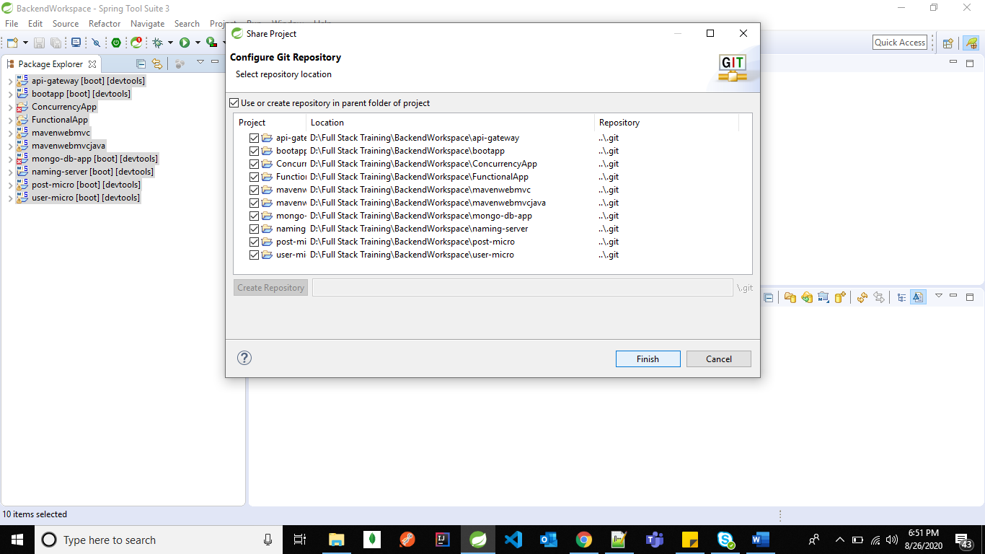](https://github.com/anuragsuman/LTI-Full-Stack-Training#)

https://github.com/Navin-Gupta/Training-Contents-LTI-July

Author : anuragsuman <68684207+anuragsuman@users.noreply.github.com>

commiter : anuragsuman <68684207+anuragsuman@users.noreply.github.com>

git remote add origin git@github.com:anuragsuman/Spring-Security.git

anuragsuman@github.com:anuragsuman/Spring-Security-Step-By-Step.git

https://anuragsuman@github.com/anuragsuman/LTI-Full-Stack-Training.git